How to download GIS data:

Soil:

1. Begin by pulling up the USDA Web Soil Survey (<http://websoilsurvey.sc.egov.usda.gov/App/WebSoilSurvey.aspx>)
2. After zooming to the area you would like to study, you must select and Area of Interest (AOI) with the AOI tool on the Interactive Map panel. Try to keep the AOI as close to a square as possible. Note that the Web Soil Survey limits the size of AOI’s.

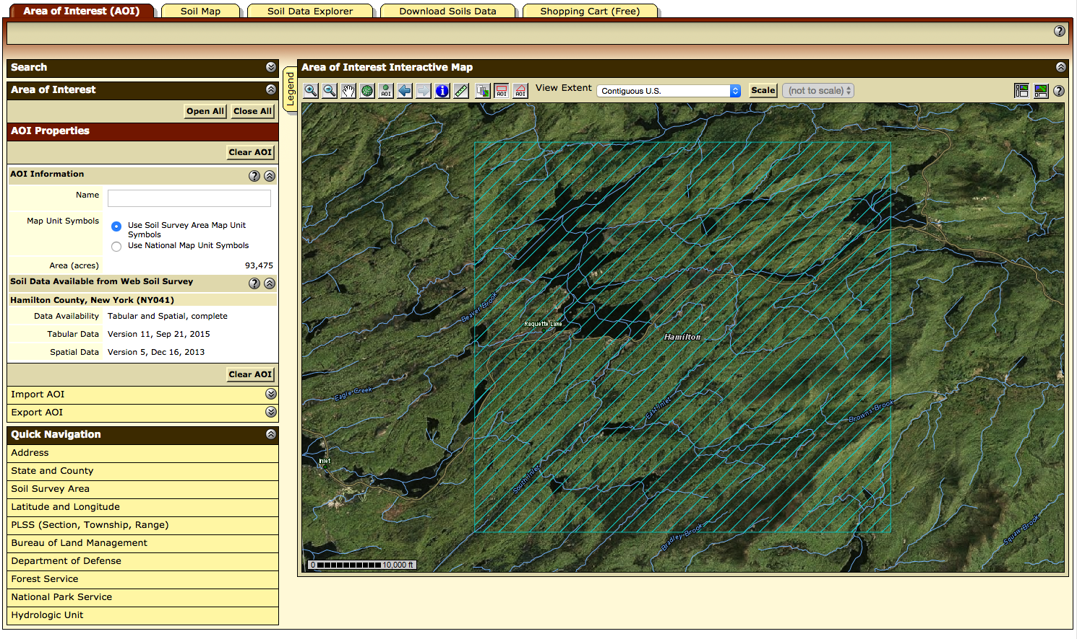

1. Once you have selected your AOI, you can go the “Download Soils Data” tab and click “Create Download Link”. Once your download link has been created, download it by clicking it. 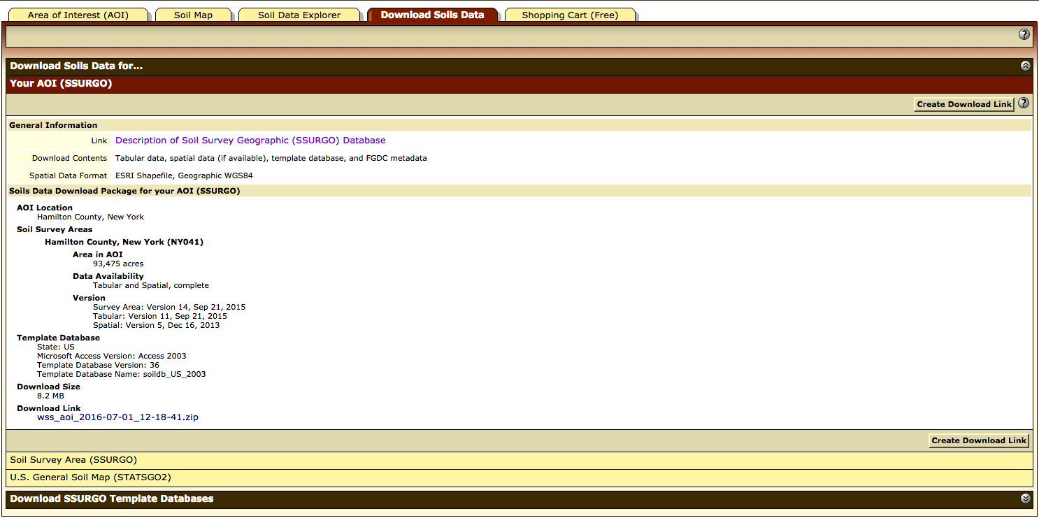

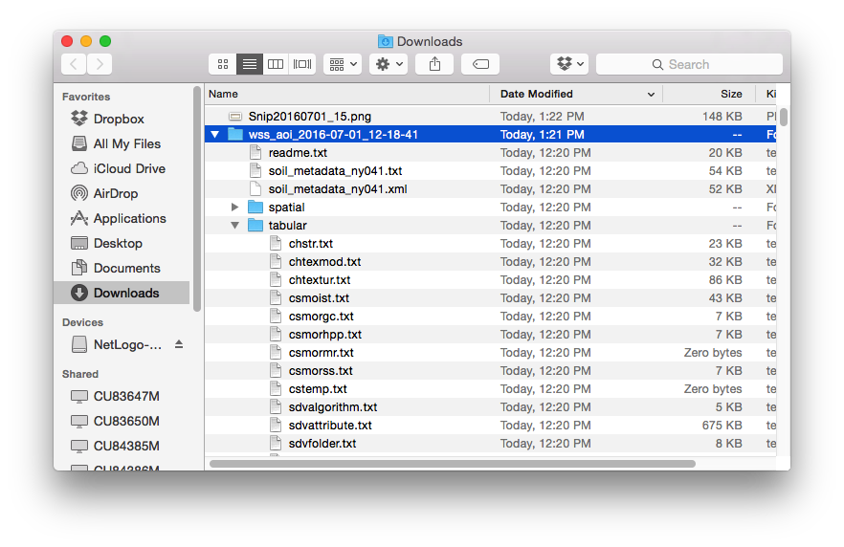

Once the file has been downloaded and unzipped, copy the “spatial” folder from the contents and paste it into the simulations/*save_name*/input/soil/ folder.

1. Next, you must create the map key. Begin by creating a file in excel titled “map_key.csv”. Go to the Soil Properties and Qualities Tab.

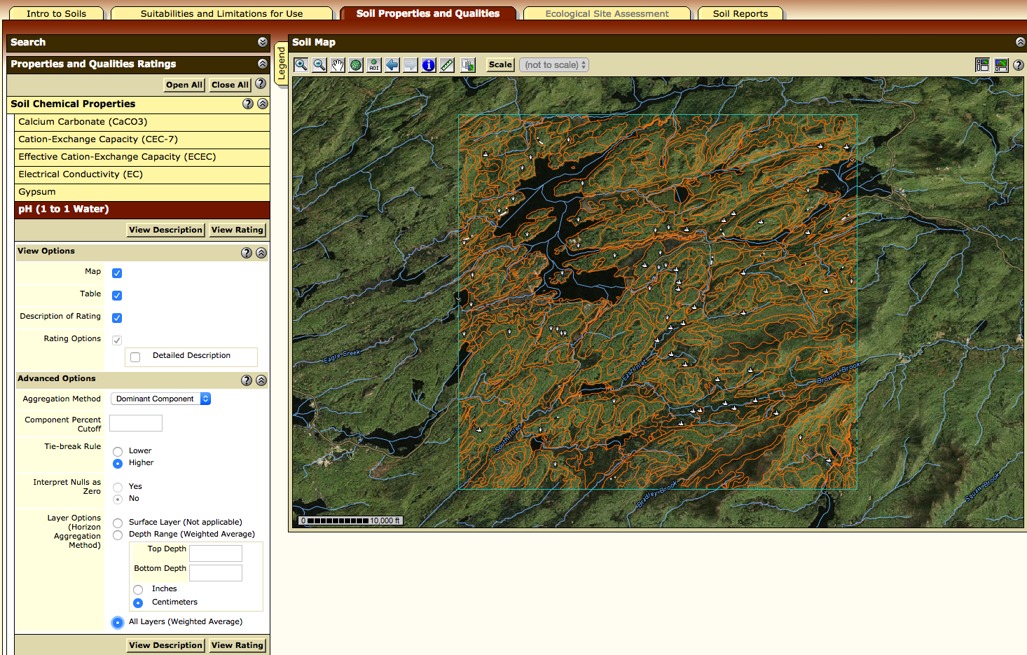

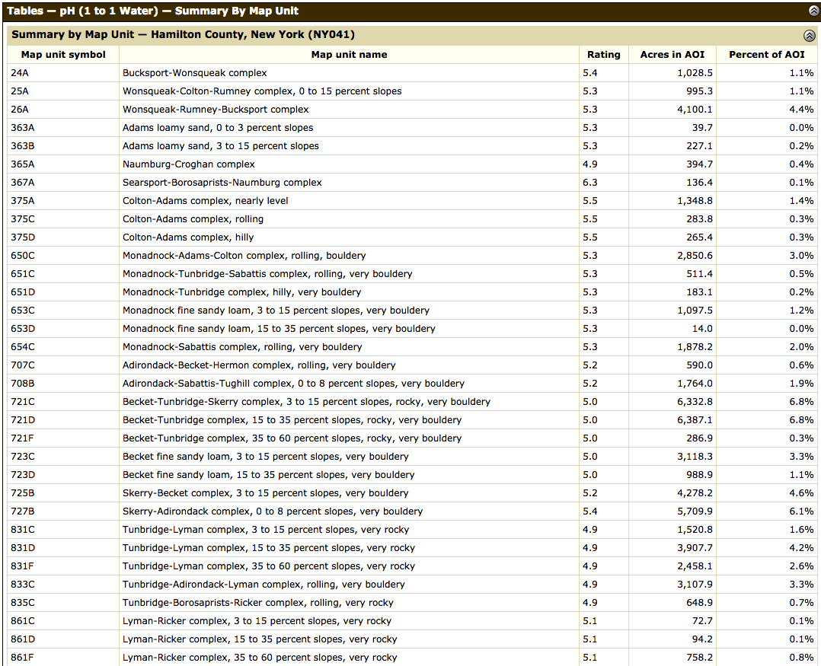

Soil Chemical Properties -> pH

Soil Physical Properties -> Water Content, 15 bar

Soil Qualities and Features -> Depth to Any Soil Restrictive Layer



